SAUDI SOLDIER-TURNED-ARTIST, ABDULNASSER GHAREM, PRESENTS FIRST U.S. SOLO EXHIBITION AT LACMA

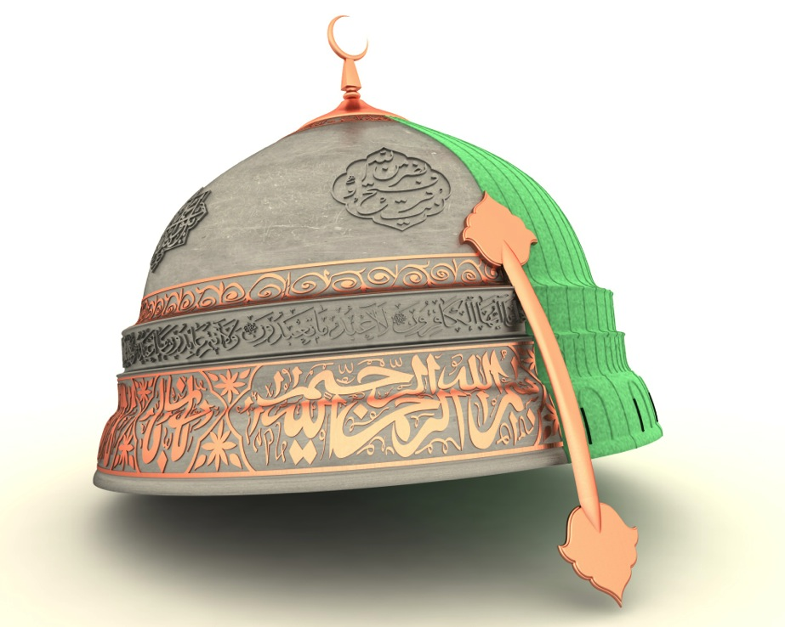

Hemisphere, 2017, Abdulnasser Gharem; image courtesy of the artist & Gharem Studio

Abdulnasser Gharem – Pause, which is the artists’ first solo exhibition in the United States, opens on April 16 and runs through July 2, 2017 at the Los Angeles County Museum of Art (LACMA). The exhibition is curated by Linda Komaroff, Curator of Islamic Art at LACMA, and presented in association with King Abdulaziz Center for World Culture.

Through works of photography, video, sculpture, painting and print, “Pause” explores themes of struggle and ideological conflict in the search for identity, felt by Gharem, in a post 9/11 Islamic world.

Abdulnasser Gharrem is an artist who chose his own path. Having been brought up in the religiously conservative Southern region of Saudi Arabia, he pursued a career in the Saudi military, reaching the rank of Lieutenant Colonel, before committing to his full-time practice as a contemporary artist.

“Gharem’s life’s path seemingly embodies the extreme polarities of artist and soldier (…),” says exhibition curator Linda Komaroff.

Several new pieces were created for this show including his monumental and eponymous sculpture, Hemisphere. Komoroff explains, “the commingling of the dome and the helmet in a single sculpture is meant to allude to the dichotomy inherent in most faiths—a message of peace and supplication versus the types of political and sectarian concerns that sometimes lead to violence.”

The exhibition’s title, Pause, refers to one of Gharem’s signature Stamp paintings depicting the catastrophic events of September 11th, 2001, which occurred while Gharem was studying at a Saudi military academy in Riyadh.

Pause will also feature many of Gharem’s most iconic artworks from the last decade, including his hand carved Stamp (Moujaz) and his iconic Siraat (The Path) print. Curator Linda Komaroff elaborates, “The media and platforms for Gharem’s art clearly borrow from the mainstreams of modern art, but the narratives and images are drawn from his everyday world, while many of his motifs—including geometric designs and floral arabesques—belong to the canon of Islamic art.”]

This exhibition was developed through a special collaboration with Gharem Studio and CULTURUNNERS.

Hires images available upon request.

ABOUT THE ARTIST:

Abdulnasser Gharem was born in 1973 in the Saudi Arabian city of Khamis Mushait. He graduated from the King Abdulaziz Academy in 1992, before attending the Leader Institute in Riyadh. In 2003, he studied at the influential Al-Meftaha Arts Village in Abha and, in 2004, Gharem and the Al-Meftaha artists staged Shattah, a group exhibition which challenged existing modes of art practice in Saudi Arabia. Since then, Gharem has exhibited in Europe, the Gulf and the USA, including at the Martin-Gropius-Bau and the Venice, Sharjah and Berlin Biennales.

ABOUT THE ART OF THE MIDDLE EAST DEPARTMENT, LACMA:

ABOUT KING ABDULAZIZ CENTER FOR WORLD CULTURE
The King Abdulaziz Center for World Culture, simply known as ithra, is a one-of-a-kind institution that brings together multiple offerings under one roof. From arts and culture to science and innovation, this bold initiative by Saudi Aramco promises a continuous journey of enrichment designed to energize the next knowledge economy of Saudi Arabia.

We aim to make a positive and tangible impact on the cultural scene by focusing on building local talents in the knowledge and creative industries. Blending iconic architectural design with advanced technology, and unique learning methods with enriching programs, ithra is an infinitely inspiring platform for explorers, learners, creators, and leaders – a thriving hub of knowledge, creativity and cross-cultural engagement.

As the Kingdom of Saudi Arabia strives to achieve its ambitious national development goals to transition to a knowledge-based economy, ithra acts as a bridge connecting cultures and cultivating a creative and innovative community.

At ithra, we believe in the power of people and ideas to unlock new possibilities: the future is what we make of it.

http://en.kingabdulazizcenter.com/

@ithra

